VT STORMWATER MANAGEMENT

FACT SHEET
Detecting and Responding to Illicit Discharges
An illicit discharge, as defined by the EPA, is any discharge to the Municipal Separate Storm Sewer System (MS4) that is not composed entirely of stormwater, except for discharges allowed under a VPDES permit or waters used for firefighting operations.
If an illicit discharge of sewage or other pollutants, typified by high turbidity, odors, floatables and unusual colors are encountered, notify Virginia Tech Environmental Health and Safety (EHS) immediately. If you know that a toxic substance was released, call the VT Police and EHS.
Illicit Discharge Indicators:

- Unusual color or cloudiness
- Dead vegetation or inhibited growth
- Surface scum or foam
- Dead animals
- Algae
- Floating debris
- Stains on channel bottom or sides
- Strong, pungent or musty odor
- Pipe corrosion
- Oil sheen

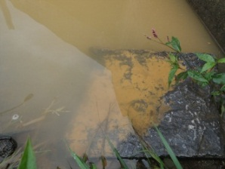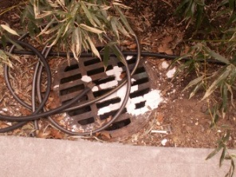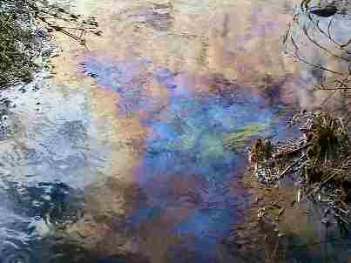
Paint/Plaster
Oil Sheen
Suds
Cloudy, Discoloration

Potential Sources of Illicit Discharges:

Sanitary wastewater
Effluent from septic tanks
Car wash wastewater
Oil spills
Laundry wastewater
Spills from roadway accidents
Vehicle and household chemicals
Construction site activities
HVAC Units

To report any illegal dumping activities, call Environmental Health and Safety at (540) 231-3600 or visit: www.ehss.vt.edu/report_issue. To report a known toxic discharge or dumping activity, call the Virginia Tech Police Department at (540) 231-6411.

